**East West University**

**Department of CSE**

**LAB REPORT**

|  |  |  |
| --- | --- | --- |
| **Course Code and Name:**  CSE209 - Electrical Circuit | | |
| **Experiment no: 08** | | |
| **Experiment name:**  Experimental Study of Sinusoids and Their Characteristics | | |
| **Semester and Year:**  Fall 2021 |  | |
| **Name of Student:**  D.M. Rafiun Bin Masud          **Student Id:**  2019-3-60-137 | **Course Instructor information:**    M Saddam Hossain Khan  Senior Lecturer  Department of Computer Science and Engineering | |
| **Date of Report Submitted:**    12.03. 2022 | **Pre-Lab Marks:** |  |
| **Post Lab Marks:** |  |
| **TOTAL Marks:** |  |

**Objectives:**1. To observe the sinusoids in the oscilloscope using a simple RC circuit.  
2. To read characteristics of the sinusoid from the oscilloscope and match the values with  
their corresponding measured values

**Simulation circuits using PSpice:**

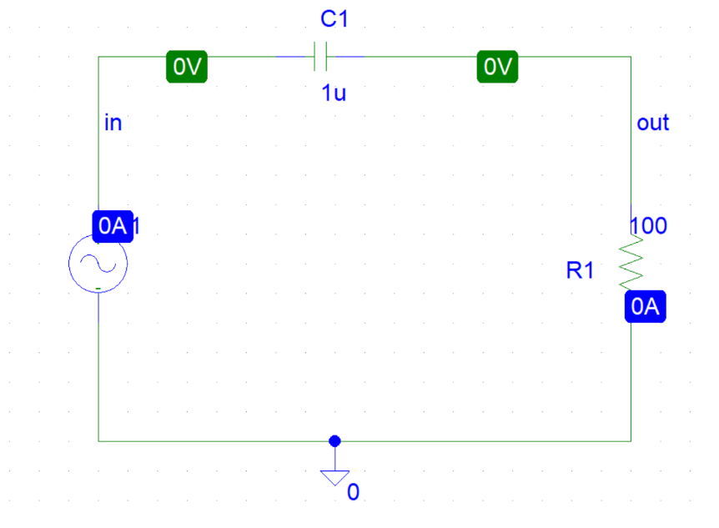

Figure 1: Circuit figure

Here,

For voltage sinusoid V1,

Amplitude, Vm = (10/2) V = 5 V

Frequency, *f* = 1 KHZ

Capacitance, C1 = 1 µF

Resistance, R1 = 100 Ω

**Graph from simulation**:

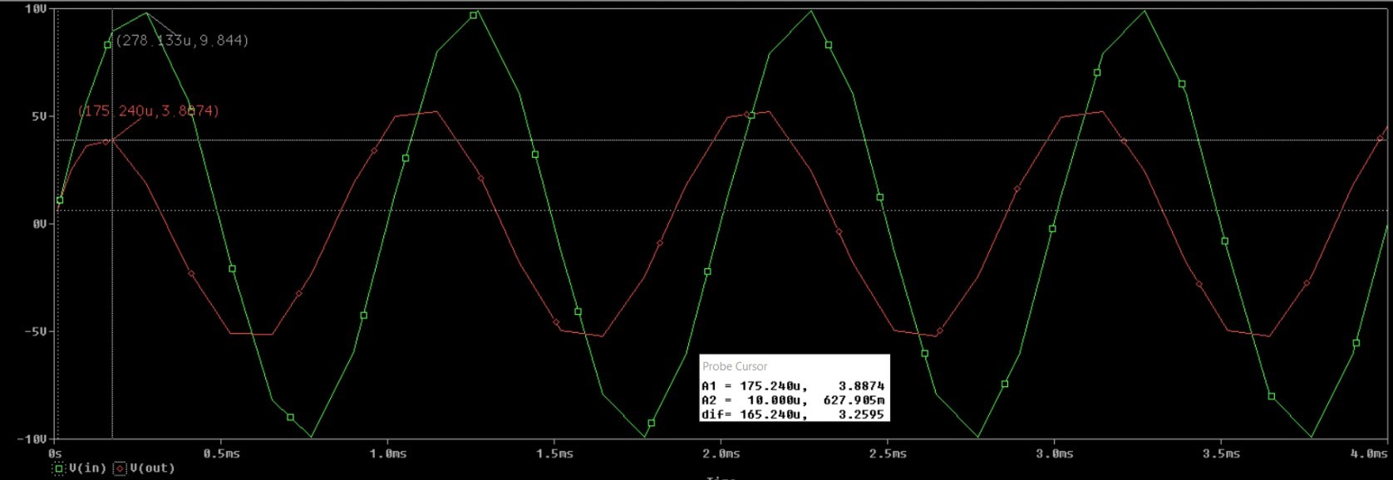Figure 2

Here,

For source voltage, peak value of Vin, Vinpk = 5 V and respect to time, tin = 1.2498 ms

For voltage across resistance, peak value of Vout, VRpk = 2.6607 V and respect to time, tout = 1.0898 ms

We know,

The RMS value of the voltage sinusoid, Vrms = Vm / √2

⸫ RMS value of source voltage,

Vinrms = (Vinpk / √2)

= (5 / √2) V

= 3.54 V

⸫ Peak value of current through resistance,

I(R1) = (VRpk / R1)

= ((2.6607 / 100) * 103) mA

= 26.607 mA

⸫ RMS value of current through resistance,

IRrms = (I(R1) / √2)

= (26.607 / √2) mA

= 18.81 mA

Theoretical RMS values from Pre-Lab,

Amplitude, Vm = 5 V

⸫ RMS value of source voltage,

Vinrms = (Vm / √2)

= (5 / √2) V

= 3.54 V

Current, I = 26.6 mA

⸫ RMS value of current through resistance, IRrms = (I / √2)

= (26.6 / √2) mA

= 18.81 mA

**Table 1.** Experimental Data from Oscilloscope.

|  |  |  |  |  |  |
| --- | --- | --- | --- | --- | --- |
| Simulated value of resistance  (Ω) | Peak-to-peak value of source voltage  (V) | Source frequency  (KHz) | Simulated peak value of current through resistance  (mA) | Simulated phase difference between voltage and current  (deg) | Which signal is leading? |
| 100 Ω | 10 V | 1 KHz | 51.99 mA | 57.6 $°$ | V(out) |

**Table 2.** Experimental Data from Meter Reading

|  |  |  |  |
| --- | --- | --- | --- |
| Simulated RMS value of source voltage  (V) | Simulated RMS value of  voltage across capacitor  (V) | Simulated RMS value of  voltage across resistance  (V) | RMS value of current through resistance  (mA) |
| 7.071 V | 5.58 V | 3.69 V | 36.98 mA |

Post-lab Report Questions:

**1.**

Comparison voltage between PSpice simulation and Theoretical RMS Values:

|  |  |  |
| --- | --- | --- |
|  | **PSpice RMS values** | **Theoretical RMS value** |
| **Vinrms (V)** | 3.54 | 3.54 |

This comparison shows that there are no discrepancies of voltage between PSpice simulation and Theoretical RMS Values. But in experimentally calculated values there can be some discrepancies between the theoretical values and oscilloscope.

**2.**

Comparison current between PSpice simulation and Theoretical RMS Values:

|  |  |  |
| --- | --- | --- |
|  | **PSpice RMS values** | **Theoretical RMS value** |
| **IRrms (mA)** | 18.81 | 18.81 |

This comparison shows that there are no discrepancies of current between PSpice and Theoretical RMS Values. But in experimentally calculated values there can be some discrepancies between the theoretical values and oscilloscope.

**3.**

We have the simulated values,

Voltage, Vin = 5 V

Current, I = 26.607 mA

= 0.026607 A

For voltage,

Phase Difference, φ = 0°

So, Polar form of VSin = 5  0°

For current,

Time period,

⸫ T = $\frac{1}{f}$

= $\frac{1}{1000}$ [⸪*f* = 1K HZ]

= 1 ms

⸫ Δt = tin - tout

= (1.2498 – 1.0898) ms

= 0.16 ms

Phase Difference,

φ = (Δt/T) * 360°

= (0.16/1) * 360°

= 57.6°

So, Polar form of I = 0.026607  57.6°

For resistance,

Resistance, R = 100 Ω

So, impedance value of resistance, ZR = 100 Ω

For capacitor,

Capacitance, C = 1 µF

So, capacitive reactance,

XC = (1 / ωC)

= (1 / 2π*f* * 1 * 10-6)

= (1 / 2π * 1000 * 10-6) Ω [⸪*f* = 1K HZ]

= 159.155 Ω

So, impedance value of capacitance, ZC = - j159.155 Ω

Therefore,

Impedance,

Z = R - jXC

= (100 – j159.155) Ω

**4.**

⸫ Impedance angle, φ = tan-1 (XC / R)

= tan-1 (159.155 / 100)

= 57.86°

Phase Difference, φ = 57.6°

Comparison impedance angle and phase difference:

|  |  |  |
| --- | --- | --- |
|  | **Impedance angle** | **Phase Difference from the PSpice** |
| **φ (deg)** | 57.86° | 57.6° |

This comparison shows that there are very few discrepancies between impedance angle and phase difference from PSpice but in experimentally calculated values there can be some discrepancies between the impedance angle and oscilloscope.

**Pre-lab Report:**

